


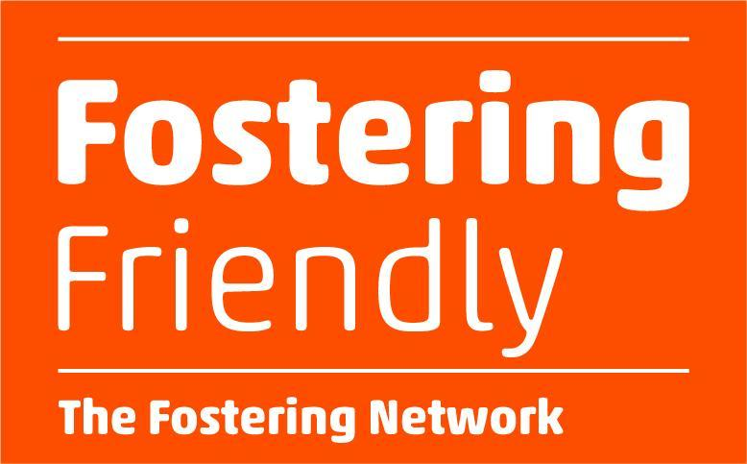

Team Administrator

Job Description
The Chartered College of Teaching is currently working on a number of new projects and we are looking for a highly-motivated and organised administrator to support our team at this exciting time.
Join our charity as a Team Administrator, helping us to support teachers, champion great teaching and raise the status of the profession by supporting the charity’s operations and providing great customer service for current and prospective members with general enquiries, applications, and renewals.
Job Title | Team Administrator
Reports To | Teacher Development Engagement Manager
Salary | £26,000 pa
Contract | Fixed term for 6 months initially, with possibility of extension
Hours | 35 hours per week. We are open to considering applications from individuals interested in working on a part time basis (minimum 0.8 FTE, 28 hours per week)
Benefits | Flexible working, generous annual leave, 8.5% employer pension contribution, Paycare, individual and team professional development/learning budget. A full list of our benefits can be found here.
Based | Office / hybrid. Currently twice a month in the office (based in central London) is required. Home-based working also considered.
Start date | Immediate start, or by January 2025
Deadline | We will be reviewing applications and interviewing on a rolling basis so we will interview as soon as a suitable candidate is identified.  Interviews will consist of a task and competency-based interview.
Application | Please apply here by uploading your CV and cover letter. Please use the guidance when writing your cover letter. We encourage you to apply promptly as we will be reviewing applications as they are received and may complete the process earlier than expected if an excellent candidate is identified at an early stage​.

The Organisation
The Chartered College of Teaching is a charity and the professional body for teachers. We are working to empower a knowledgeable and respected teaching profession through membership and accreditation.
We are dedicated to bridging the gap between practice and research and equipping teachers from the moment they enter the classroom with the knowledge and confidence to make the best decisions for their pupils.
We are a growing and multi-skilled team of 30 people, supported by a Board with a significant track record of experience in a range of fields. Our business plan focuses on growing membership and Chartered Status, and providing meaningful professional learning opportunities for the teaching profession.
The opportunity
We are looking for a highly-motivated and organised Team Administrator to join the charity. This is an exciting opportunity for someone who wants to develop their customer service and administrative skills.
Reasons why this role could be great for you:
- You will have autonomy for delivering excellent customer service to our members and offer them a seamless experience, providing timely communications and responses to queries and phone calls
- You enjoy interacting with people and collaborating with colleagues across the organisation
- You will be helping to grow the professional membership organisation for the teaching profession and be part of the team driving the organisation forward at an exciting time for the future of the College
- You will play an important role in supporting teachers and leaders to develop in their roles, impacting on the children and young people they teach.
Main areas of work | Much of your time will be spent providing excellent customer service as one of the first points of contact for potential and existing members, with a particular focus on member support and onboarding for our courses and programmes.  You will:  - Manage and respond to queries via email and telephone, ensuring that you respond professionally and within agreed timeframes  - Support members to access their membership features, including logging to our online platforms to access courses, content and our online shop  - Set up member accounts and track membership and course activity, collating information and sharing with colleagues  - Liaise with designated school contacts to support onboarding and renewal processes  - Follow up with individuals as required to help them progress with membership and/or course completion  - Create and update templates and organisational reports  - Ensure that all contact and communications are compliant with  relevant data protection and security standards
Additional areas of work | You will also undertake a range of administrative tasks to support member accreditation and development, and member operations, including:  - Supporting administration of assessment and accreditation e.g. updating assessment records, collating exam/assessment scripts, checking references  - Inputting data into our CRM platform (Salesforce); support with data collection, data entry, and reporting (Excel/Google Sheets)  - Provide administrative support for short-term projects and other operational and team activities where required  - Performing other activities as and when required to support the wider team to achieve the charity’s goals  Alongside your main areas of work, you will also participate in meetings and be encouraged to participate in CPD learning activities and training to maintain and develop your knowledge and skills.
About you
You don’t need to have expertise in absolutely all areas, but we’re looking for someone who is motivated by our mission, enjoys interacting with people on a range of tasks and is passionate about providing great customer service. Systems you would be using include Google Workspace, Salesforce, Wordpress, Moodle, Submittable, Zoom and Slack.
Experience and skills:
- Excellent written and oral communication skills (essential)
- Experience of delivering high quality customer service, managing relationships with customers or other stakeholders and providing an excellent experience (essential)
- Confident user of technology (email, online meeting tools and Microsoft Office / Google Workspace or similar); comfortable with learning new technology systems (essential)
- Experience of Salesforce or other CRM systems (desirable)
- Experience of administration / office work (desirable)
- Knowledge of GDPR and how it relates to the storage, retention and use of personal data (desirable)
- An interest in the education sector and the support and development of teachers (desirable)

Why Us?
As an organisation we care deeply about creating a working environment that supports our people to grow personally and professionally. These are reflected in our organisational values which outline the distinctive working culture we are looking to create. In particular, these values are reflected in our commitment to:
- Flexible working: responsive management, flexible hours, hybrid or fully remote working
- Professional development, including formal and informal training and support
- Transparency and ownership: we have an open culture that ensures all staff guide our strategic direction
- Mental health and wellbeing: access to health and wellbeing advice and health cash plan.

Diversity and inclusion at the Chartered College
As a growing organisation we are committed to:
- Becoming increasingly representative of the sector and geographies that we operate in
- Providing a positive experience of work as part of an inclusive culture led by our organisational values
- Maintaining an annual EDI action plan - led by the internal team.
What to expect from the recruitment process
- All applications are anonymised until the point of interview
- Line Managers trained in recognising bias
- We implement a standardised interview template and competencies matrix for a fair and transparent process
- All interviews are conducted via Zoom and the use of camera is optional.
If you require any adjustments in order to proceed with an application please make a request to recruitment@chartered.college.
For more information about joining the Chartered College, please watch this short video from Dame Alison Peacock (CEO).
Your Personal Data
As part of the recruitment process, the Chartered College of Teaching collects and processes personal data relating to job applicants. The organisation is committed to being transparent about how it collects and uses that data and to meeting its data protection obligations.
Pre-employment checks
All conditional offers of employment are subject to:
- Two satisfactory references
- Proof of qualifications
- Eligibility to work in the UK.
We are an employer committed to the safeguarding of children and young people.

